 |  | R V College of Engineering  Department of Computer Science and Engineering  CIE - II: Question Paper
Subject :  (Code) |  | COMPILER DESIGN (CS363AI) |  |  | Semester : 6th BE
Date : JUNE 2025 |  |  | Duration : 120 minutes | Staff : DD/SB/SNM/SMS
Name : |  |  | USN : | Section : A,B,C,D
Si.No | Part A  Quiz Questions |  |  |  |  |  | M | BT | Co
1. | What is the meaning of LR(k) grammar. Give an example.  Reading from left, applying RMD in reserve order looking k symbols ahead. --- 1M  Example -1M |  |  |  |  |  | 2
2. | Consider the grammar below:  S->SS+ | SS* | a  If I ={S->S.S+} compute Closure of (I).  Closure(I)={ S->S.S+, S->.SS+, S->.SS*, S->.a} |  |  |  |  |  | 2
3. | Consider the grammar below:  S->bAc | dC| bdA  A->d  C->k  Compute the Canonical set of LR(1) collections for the starting state.  S’->.S,$  S->.bAc,$ | .dC, $| .bdA, $ |  |  |  |  |  | 2
4. | What is an L-attributed SDD? Give an example.  L- Attributed SDD can have both synthesized and inherited attributes for the nodes of the annotated parse tree. –1 M  Example—1M |  |  |  |  |  | 2
5. | What is the relationship between activation record and control stack?  Procedure calls and returns are usually managed by run-time stack called the control stack . Each live activation has an activation record on the control stack. |  |  |  |  |  | 1
6. | List the properties we desire of memory manager.  Space efficiency, program efficiency, low overhead |  |  |  |  |  | 1
 | Part B
1. | 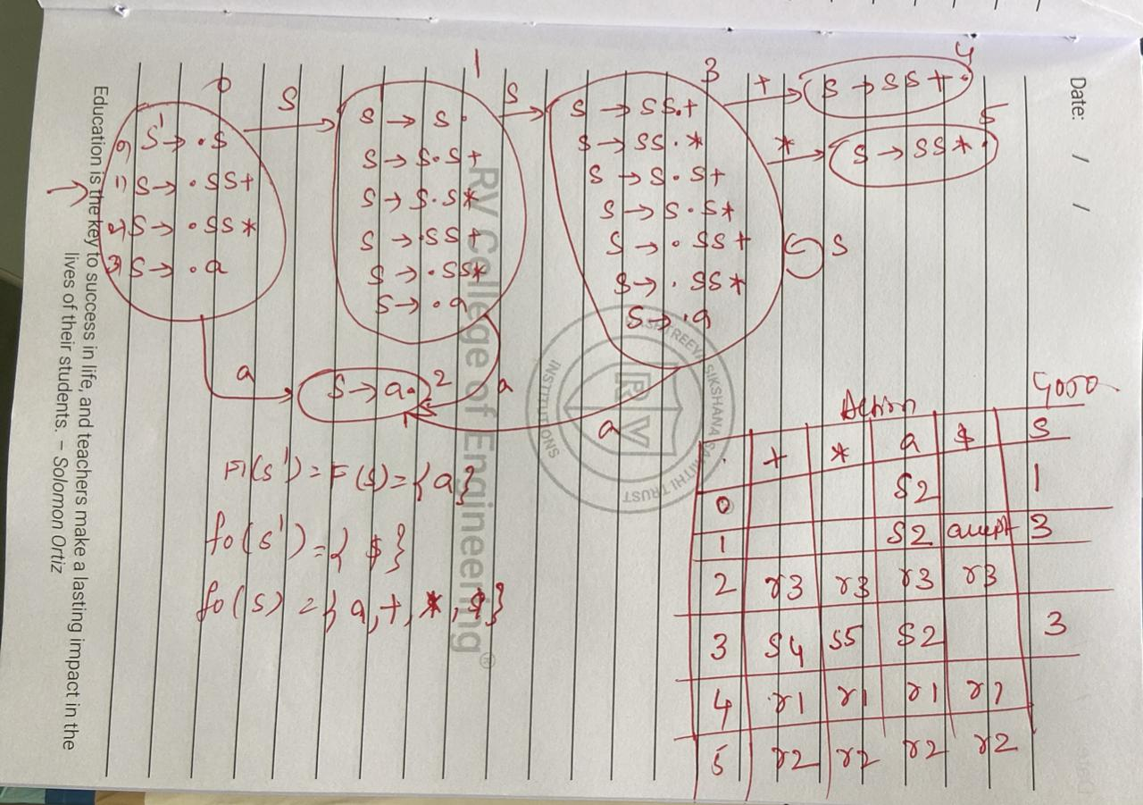  LR(0) automata – 4 Marks  Parsing table – 3 Marks  Parsing – 3Marks
2 | 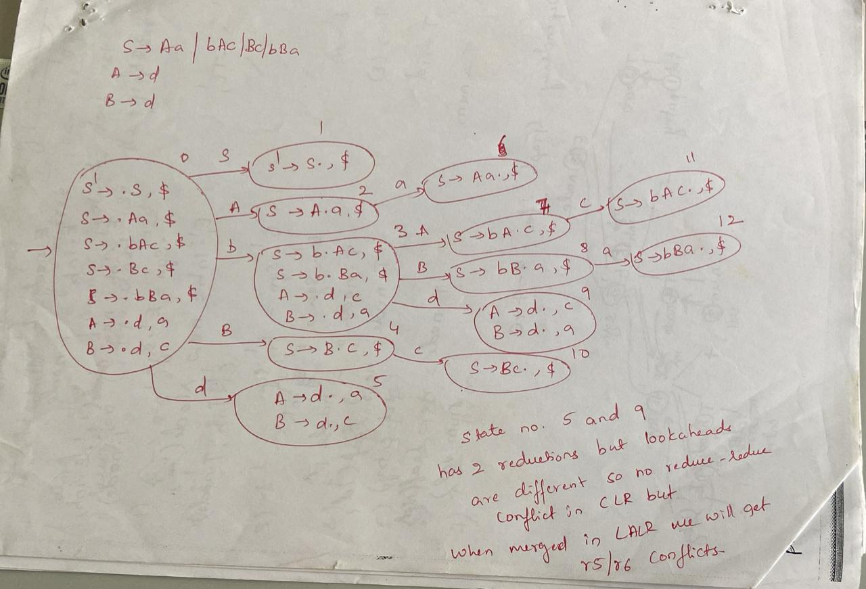  LR(1) automata – 4marks  Parsing table construction for CLR(1) or LALR(1) – 4marks  Justification for not LALR – 2 marks
3 | SDD --- 5 marks  Annotated parse tree – 5marks  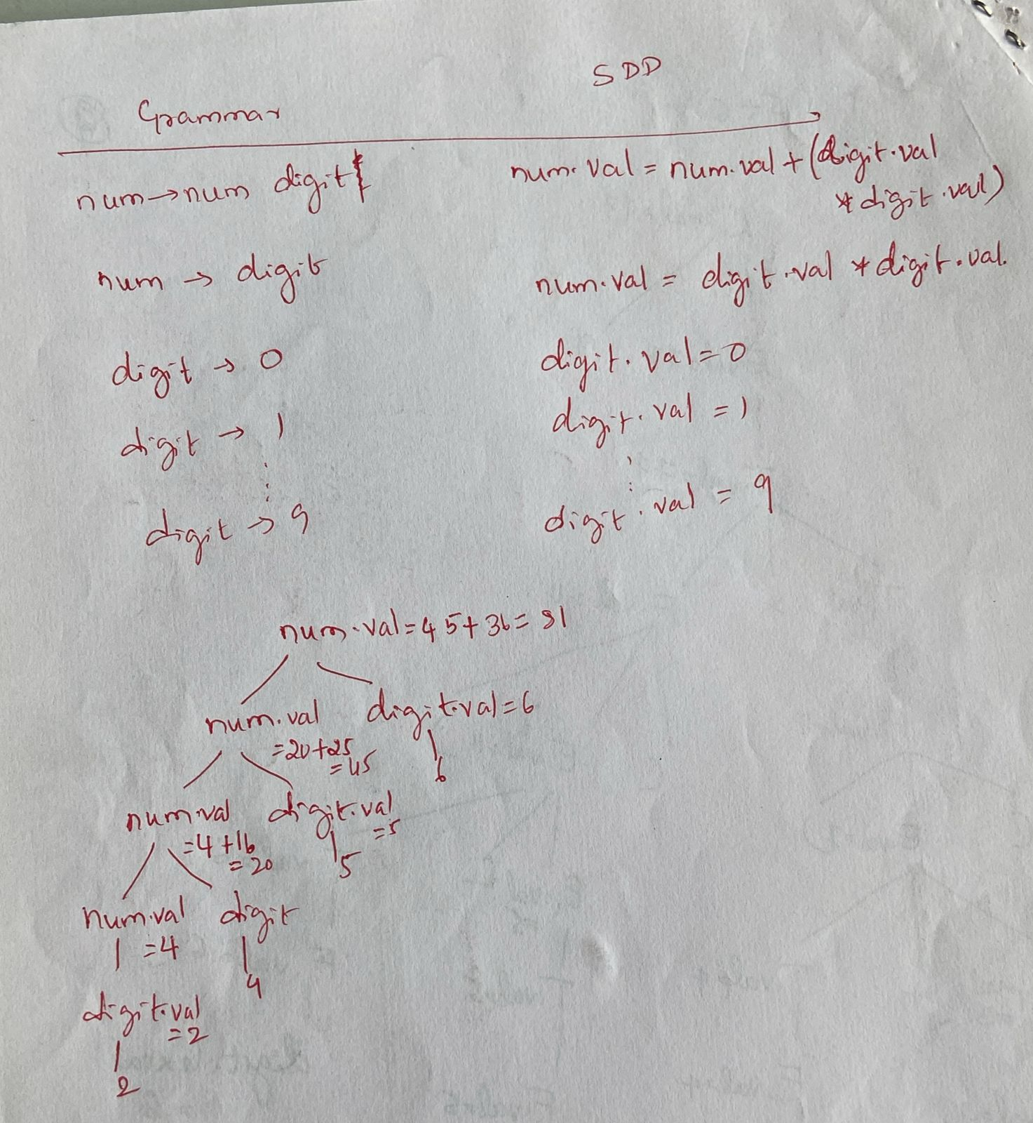
4a. | Any one of the following:  Creating syntax tree or defining structure of a type with sematic rules and an example 3+2 = 5marks
4b. | 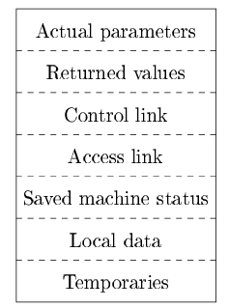  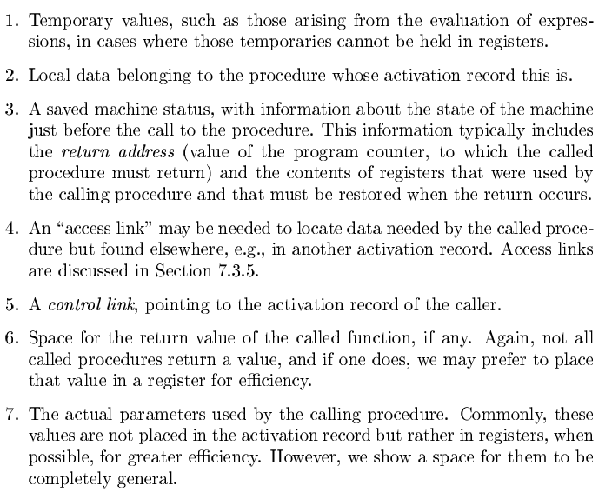  Diagram + explanation = 2+3 = 5
5. | Design principles:  - Values communicated between caller and callee are generally placed at the beginning of the callee's activation record, so they are as close as possible to the caller's activation record.  - Fixed-length items are generally placed in the middle.  - Items whose size may not be known early enough are placed at the end of the activation record.  - Wemust locate the top-of-stack pointer judiciously. A common approach is to haveitpointtotheend of the xed-length elds in the activation record.  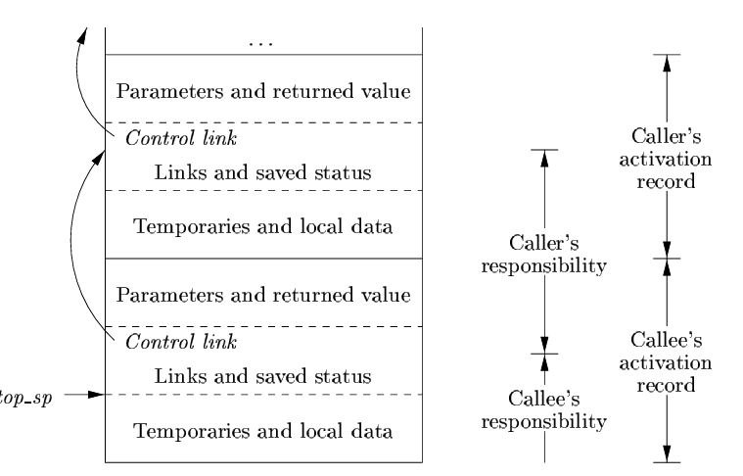  Design principles – 4 marks  Diagram – 2 marks  Explanation – 4Marks

